**Original Spec**

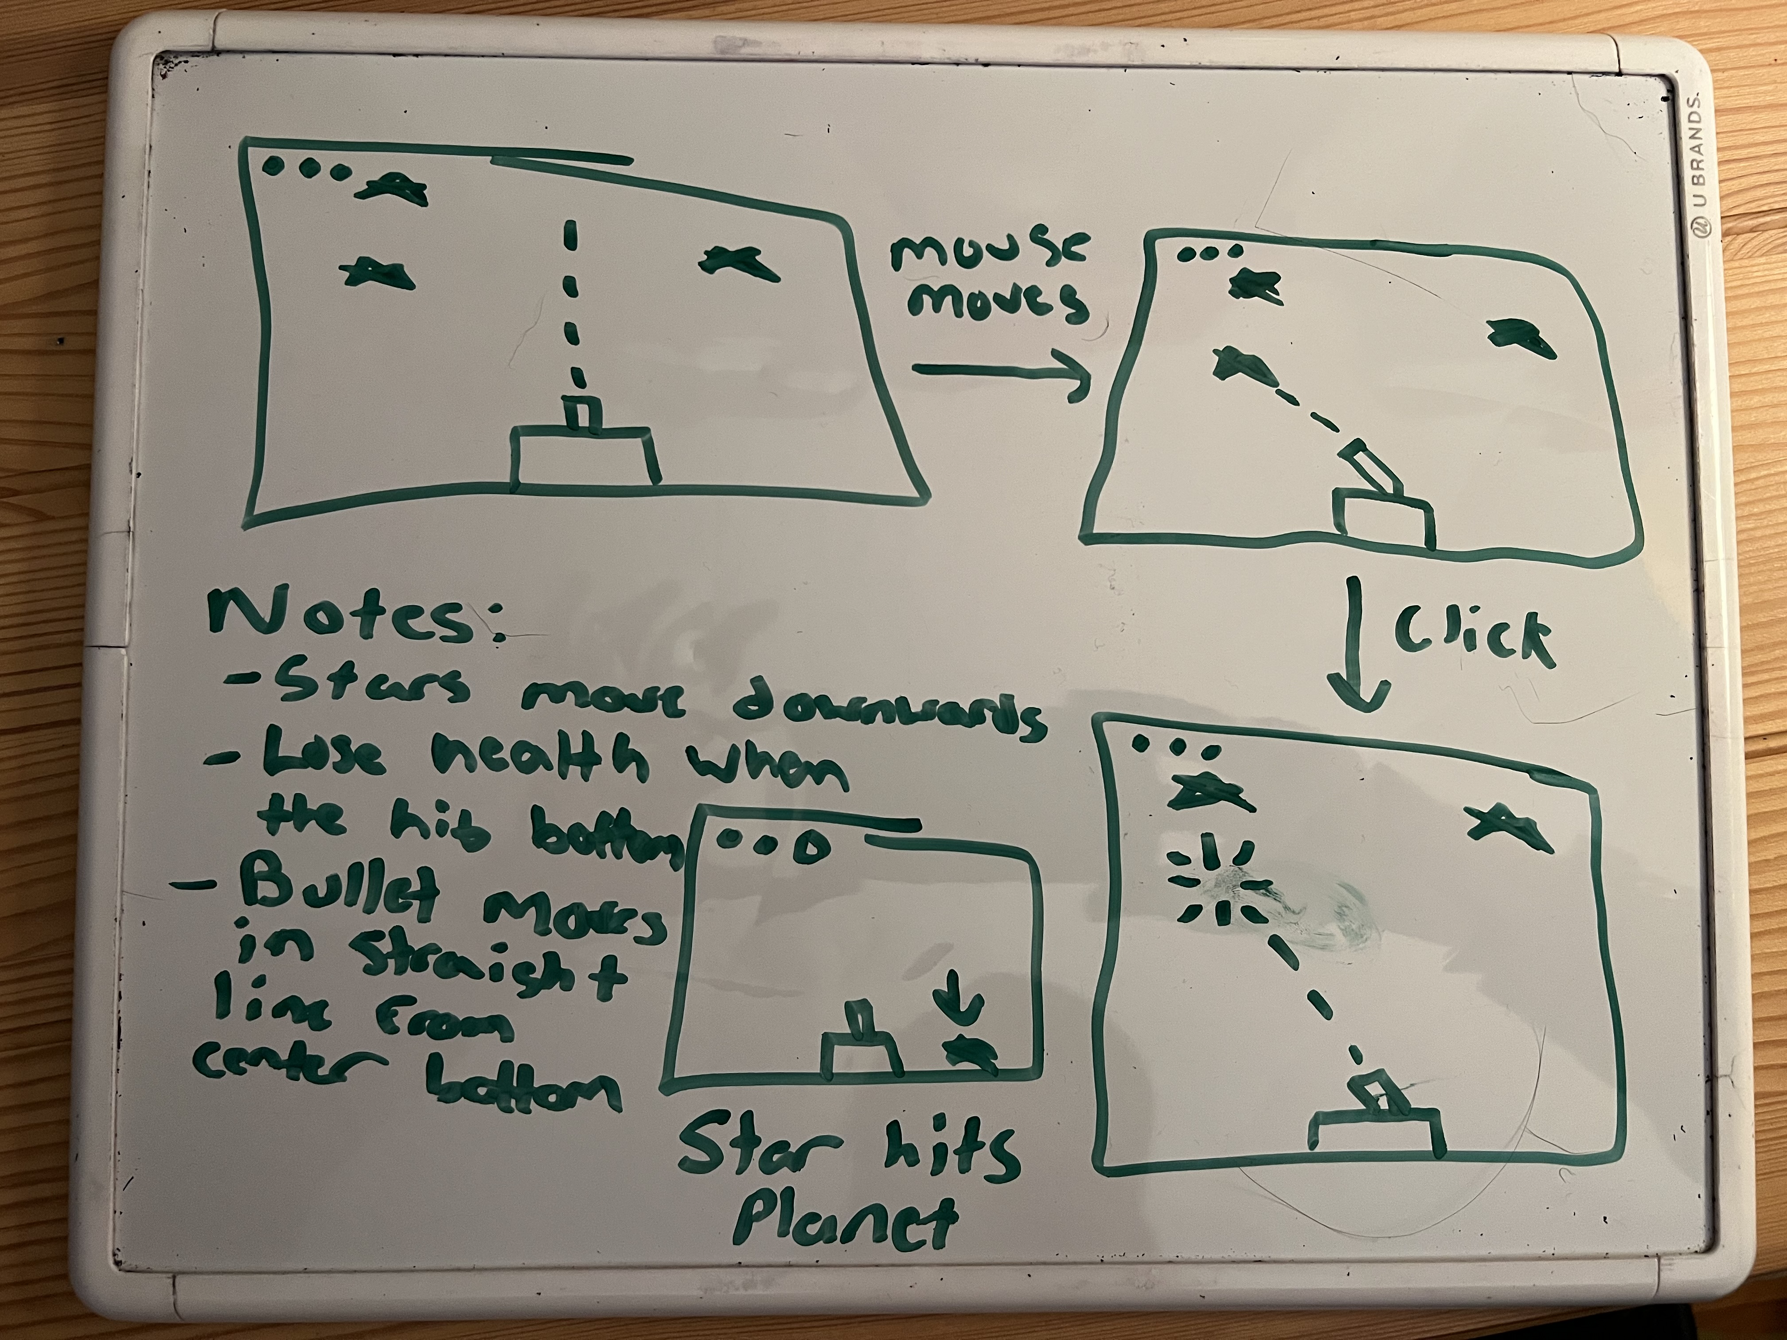

**Whiteboarding how I wanted to write screen_intercept and star_hit? (With TA Waka)**

